**If I Stay**

2016-07-02

Don’t you ever question why I’m by your side / I’m here when you cry because he told you lies so slyly / I run my fingers through your hair and show I care / But I’m not the one that your heart belongs to nightly.

I love you without regret since the day we met / If what you see’s what you get / Well I’ve had nothing yet for these past years / Tell me will you ever feel the same if my love won’t tame / Or just like cellophane / Will I call your name unto deaf ears?

But if I stay would you kiss me in the summer rain / Or let me wash away into the sand / Would we lie together underneath the burning sun / And let our two hearts beat as one.

If I stay would you let me hold you in my arms / And later take a walk beneath the stars / Tell me someday this could all be real / And end this heartache I’m pained to feel.

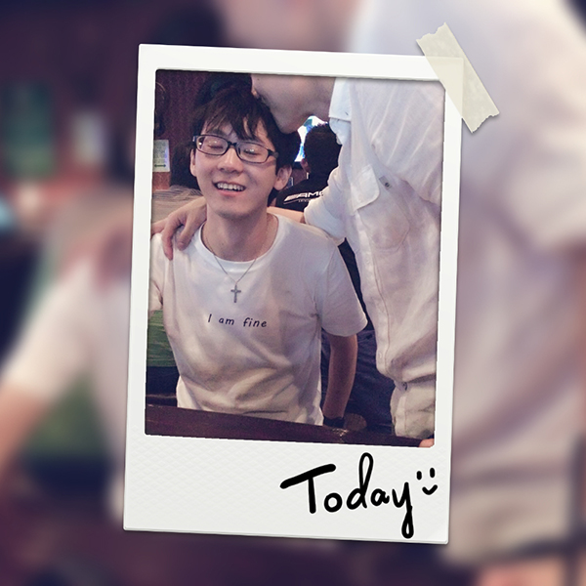

Fig. 1